Step 1: Go to the GitHub repository. <https://github.com/PriyanshuKSG/SOC_2024_mentees>

You will see like this

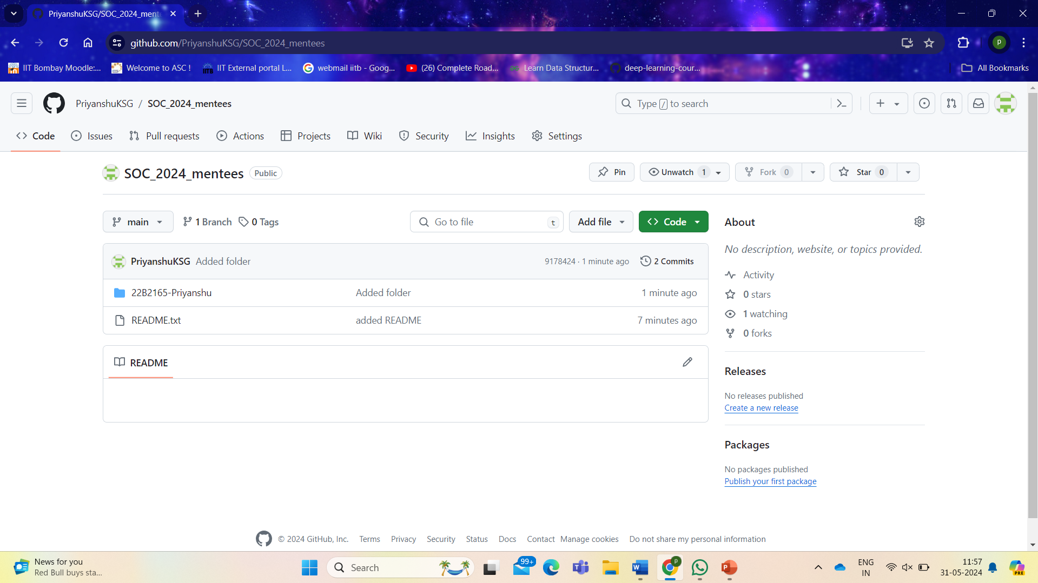

Step 2: Go to the folder on your laptop where you are currently having all the stuff like docs/files/notes/assignments etc. For eg: this is my folder.

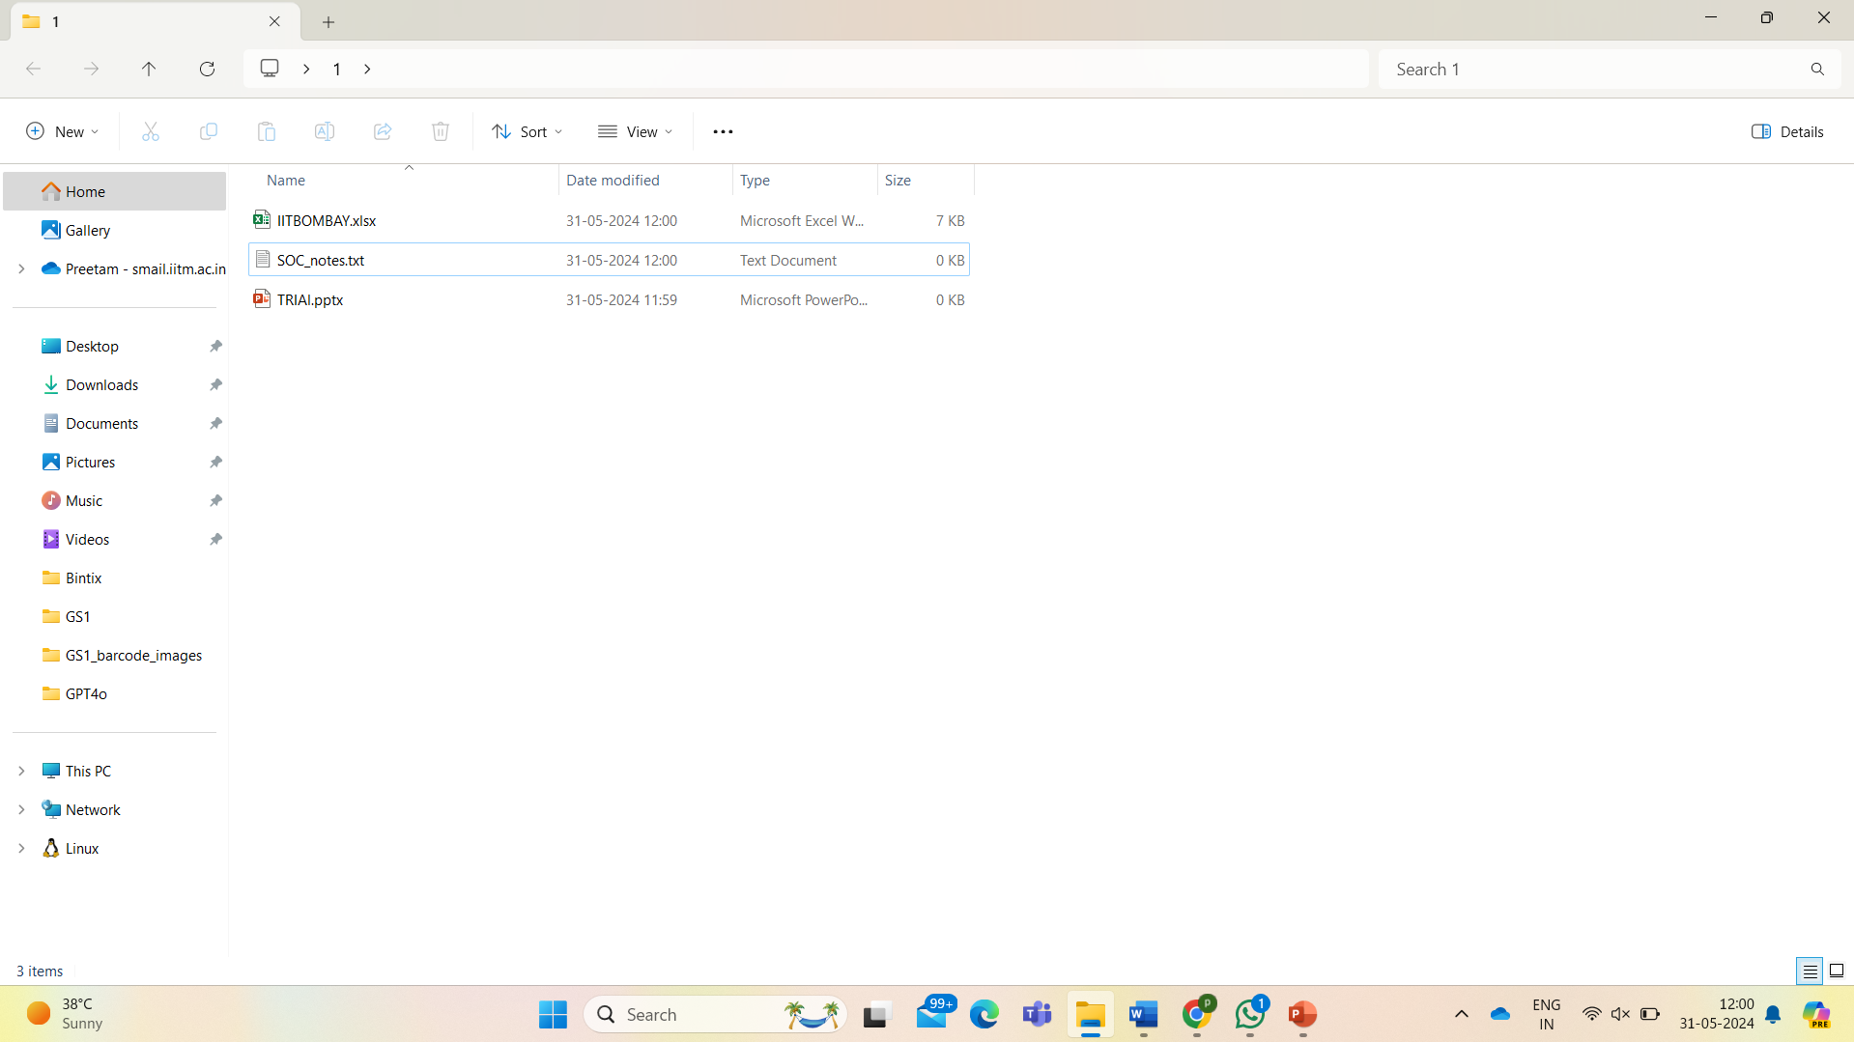

Step 3: Right click and select “Open in Terminal”. You should see like this.

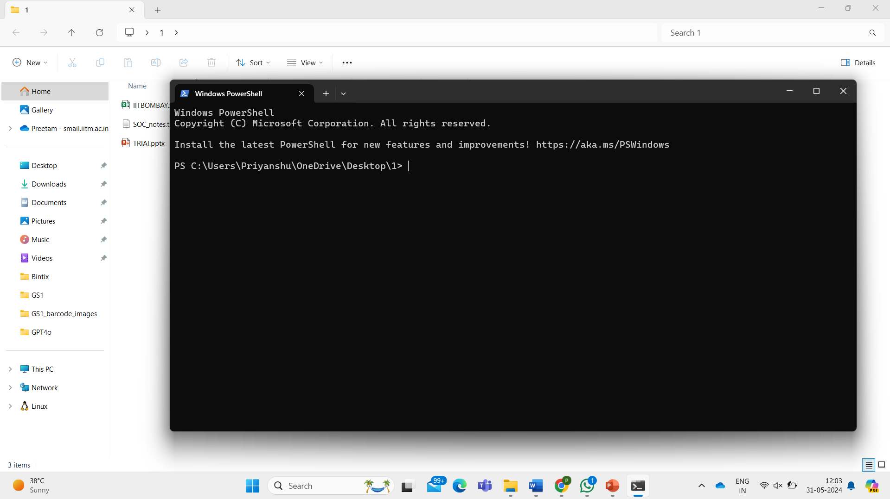

Step 4: Copy the URL of the repository: <https://github.com/PriyanshuKSG/SOC_2024_mentees>

Step 5: Write in terminal git clone paste_the_url

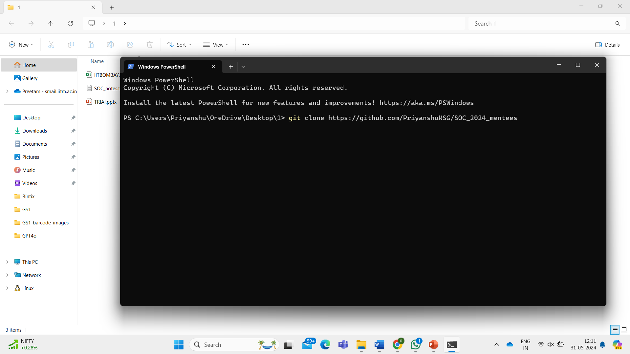

Now you will see a new folder like this

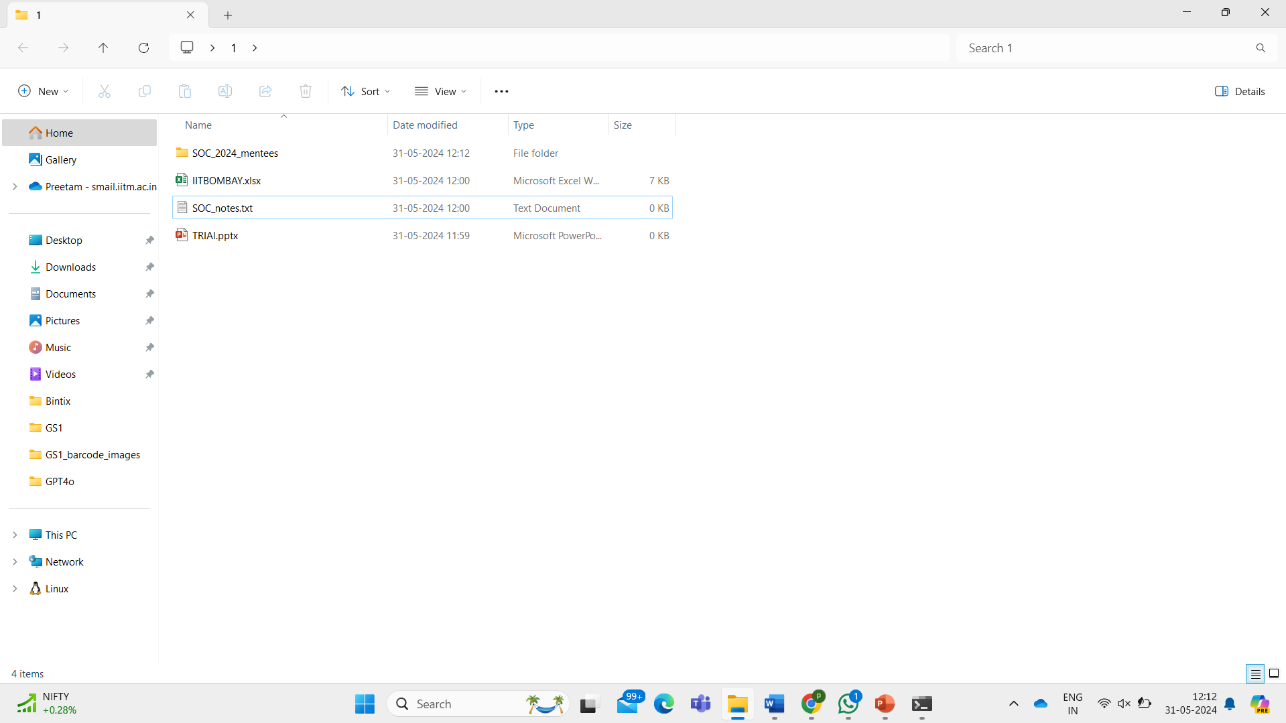

Step 6: Now make changes in the SOC_2024_mentees folder. I will add my three files into 22b2165-Priyanshu folder inside the SOC_2024_mentees folder. Always copy the files. Do not cut and paste. You should always have backup for your files.

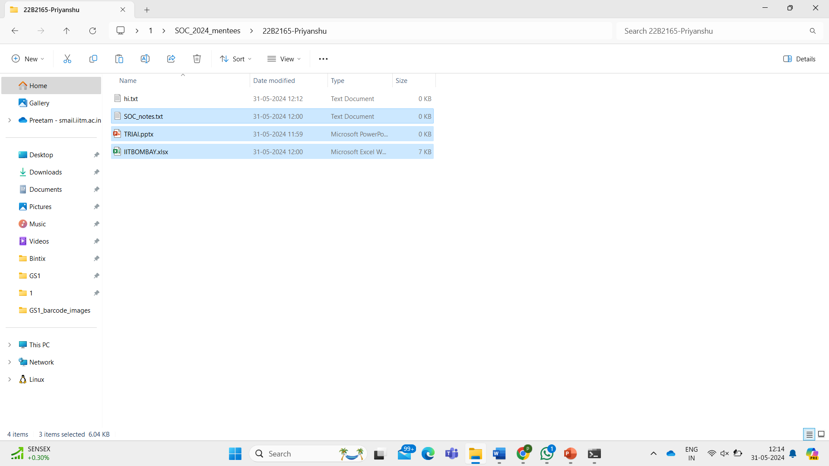

As you can see, I have added my files.

Step 7: Write cd SOC and then press tab key on keyboard. You should see like this.

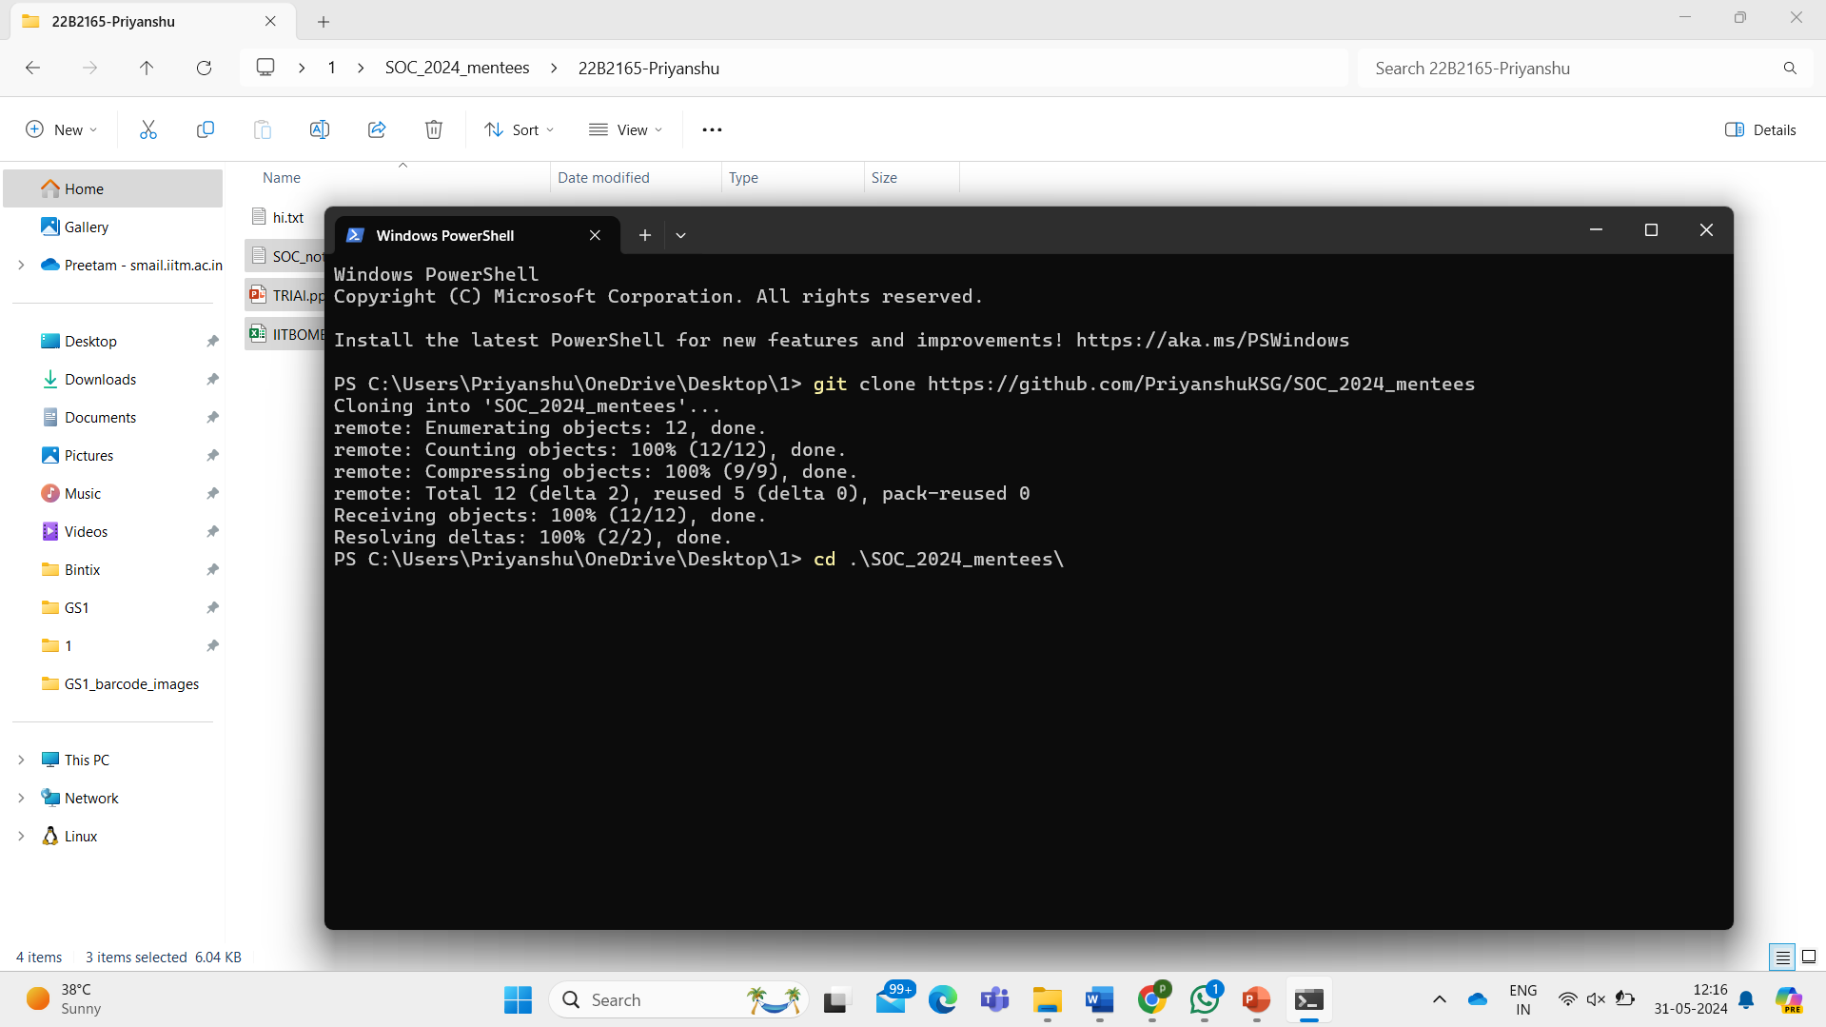

Now we are inside the SOC_2024_mentees folder.

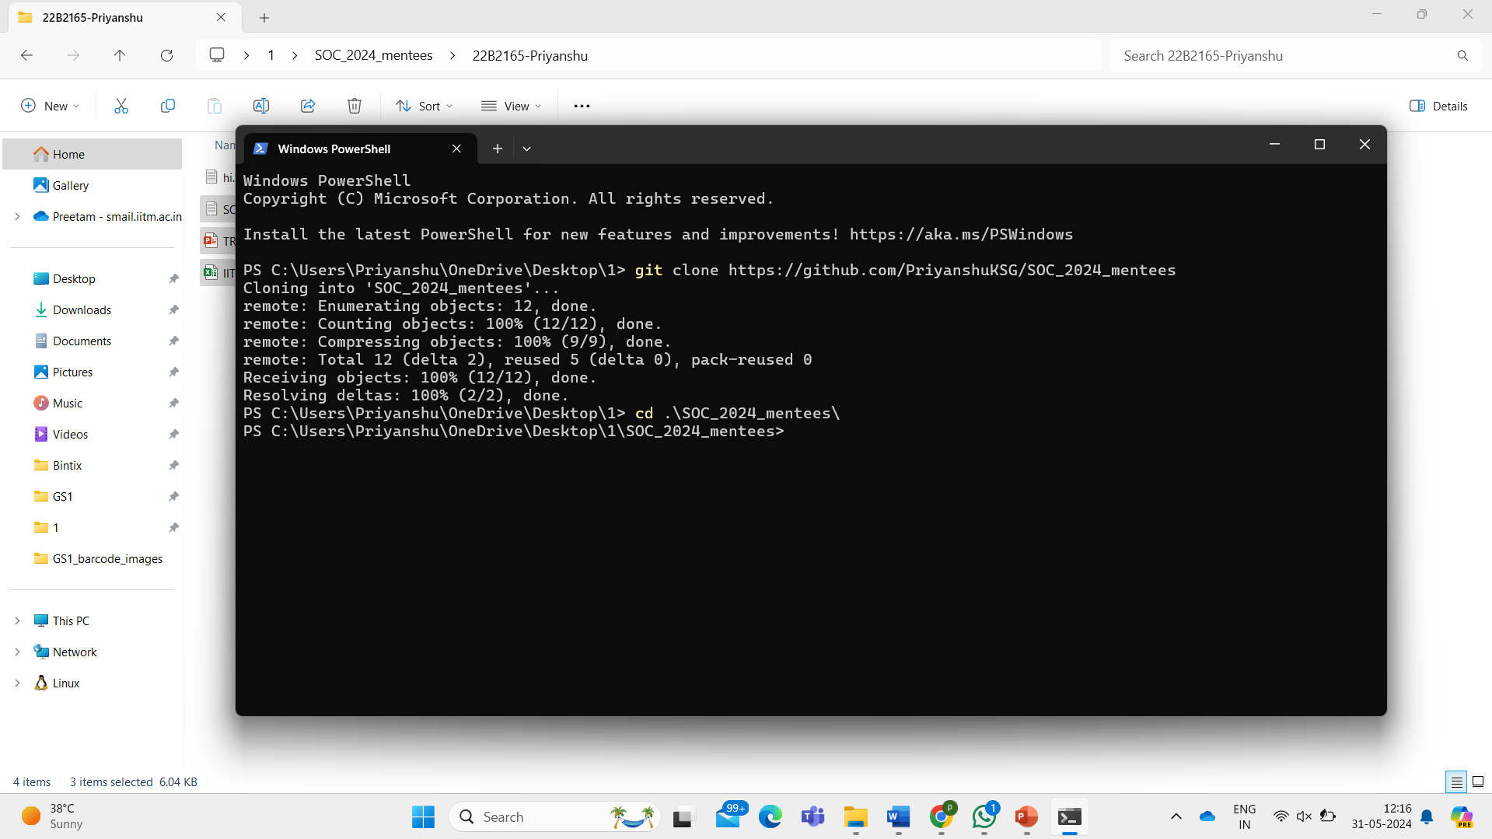

Step 8: Write git status and press enter. You shall see like this. Whatever files you have added will be shown in red color.

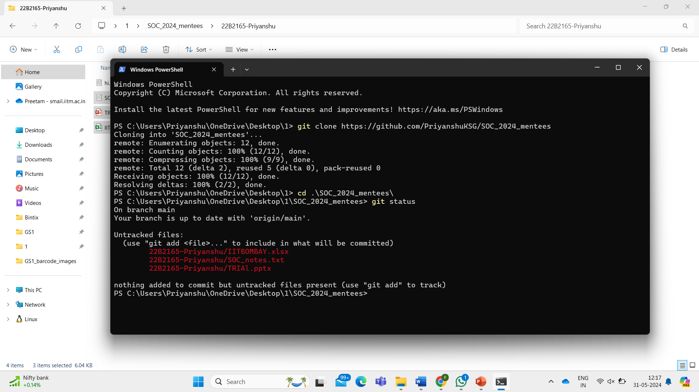

Step 9: Write git add . (git space add space dot)

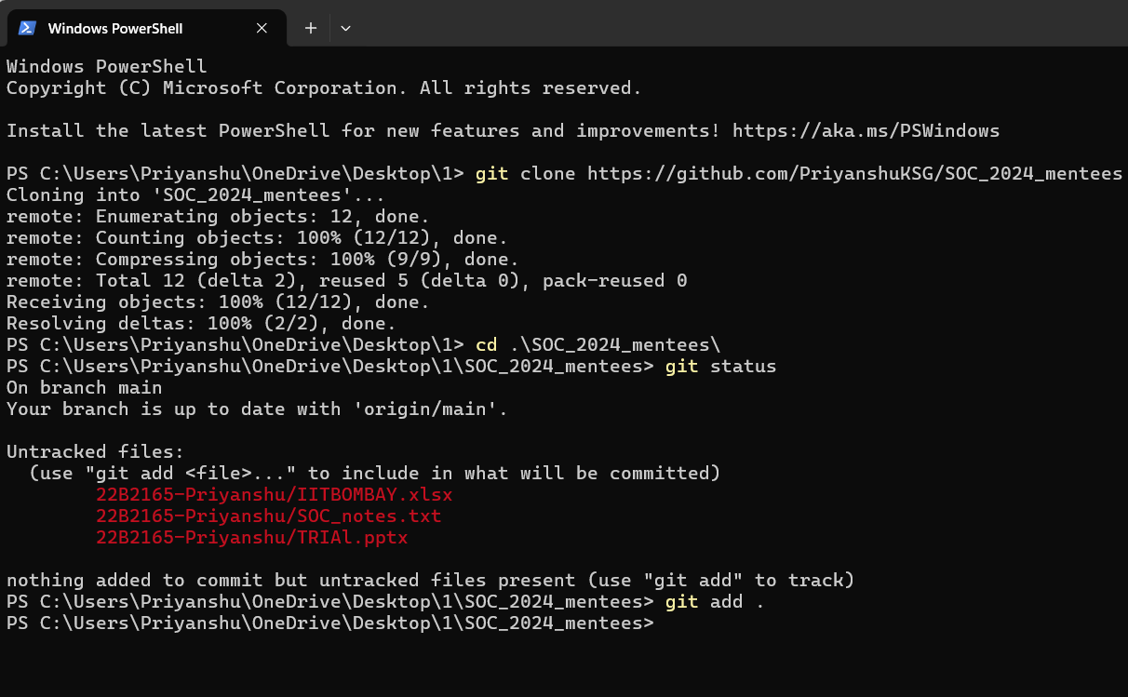

Step 10: Again, write git status. The files shown in green means that they have been successfully added.

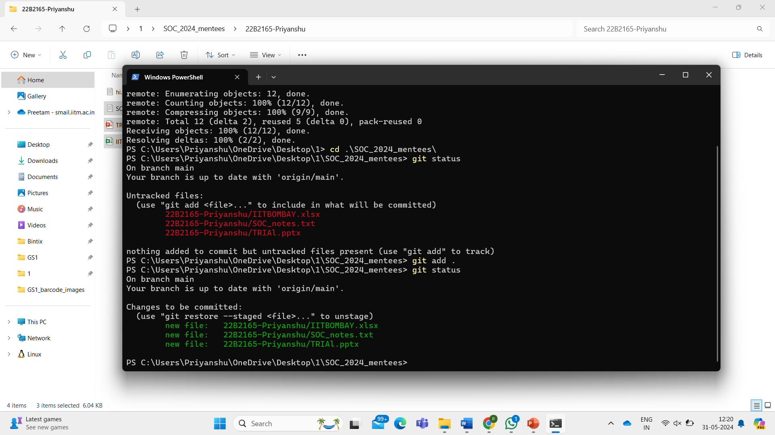

Step 11: Write git commit -m “any message”. (git space commit space -m space “your message”)

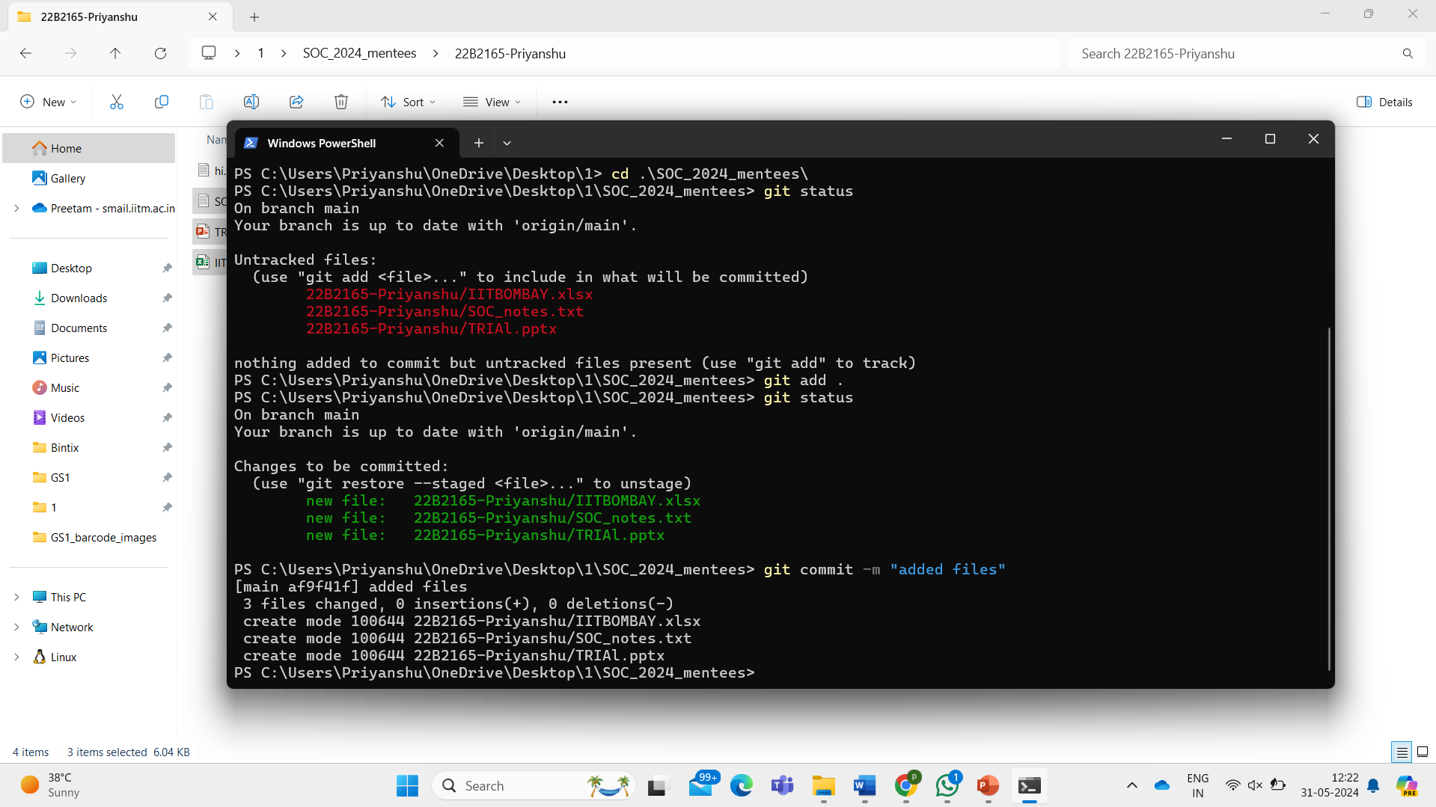

Step 12: Write git push origin main

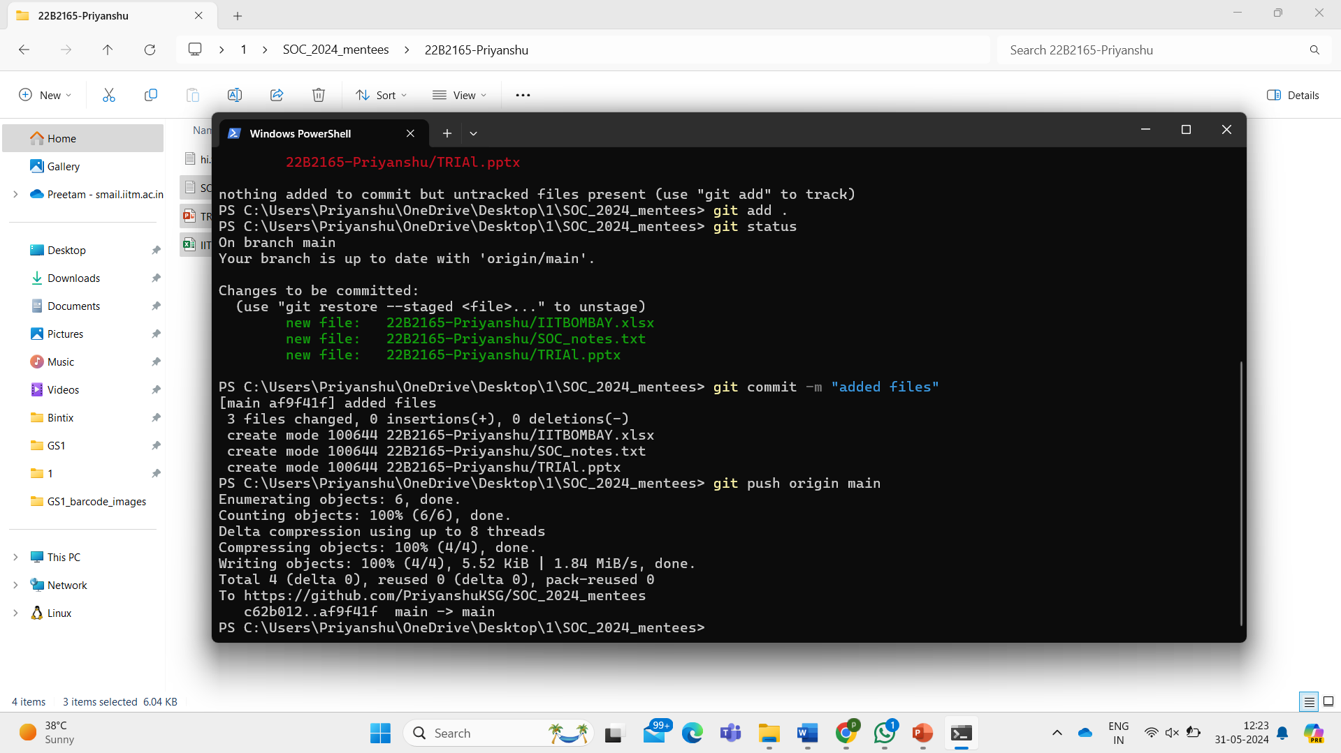

Step 13: Go to GitHub page and refresh. (Ctrl + R)

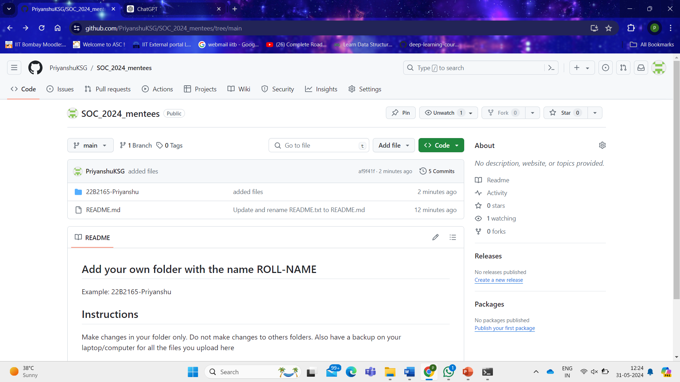

As you can see, I have added my files in my folder in GitHub repository.

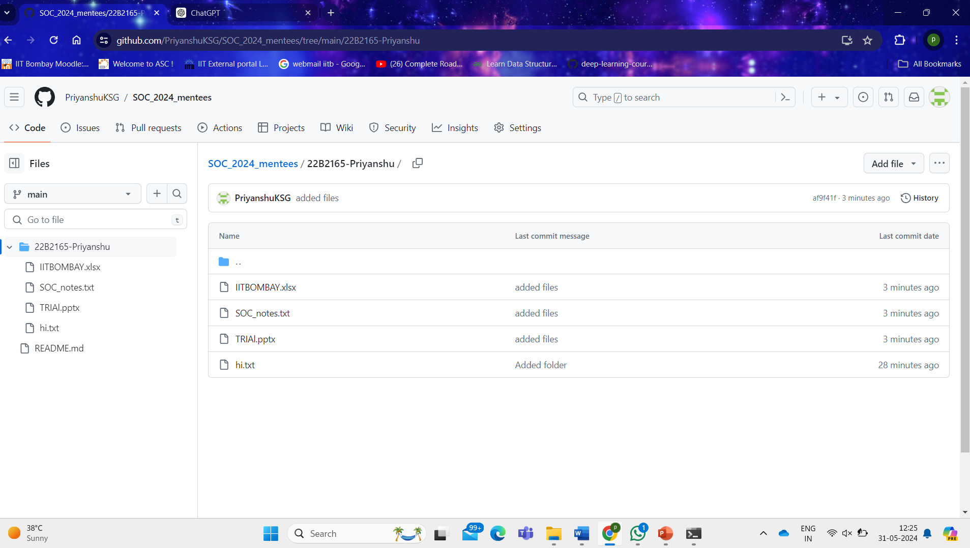

Step 14: Delete the SOC_2024_mentees folder from your local machine.

YAY!!

You now know how to use Git and GitHub.